Entr 202
Innovation
Assignment – Attribute Dependency
Name: _________________________
Example attribute dependency table
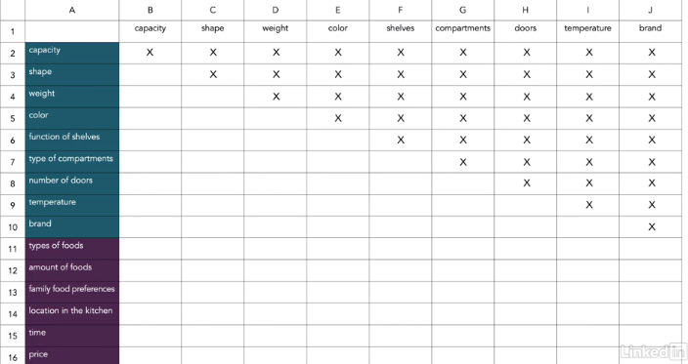

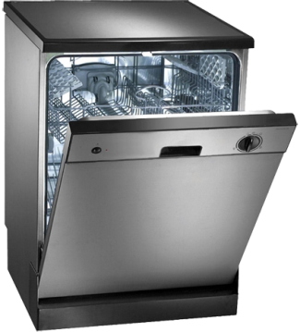
Utilize the steps in the Attribution Dependency technique. Complete the table (see example above) for both current industry products and one you could develop. The product you will use is: a dishwasher

- – In an excel spreadsheet, list the internal and external attributes of the dishwasher. Mark the attributes that currently have an attribute correlation/dependency and insert the table into this document

- Using the same table, mark 2 attributes that that currently do not have an attribute correlation/dependency and insert the table into this document

- Explain in detail how you could create a new product with these 2 examples of attribute dependency and what the value would be to consumers

